Identity DAO Spec v0.4



dOrg – GoodDollar Project

Ori Shimony
Luis Dominguez

07.09.19

I. Overview

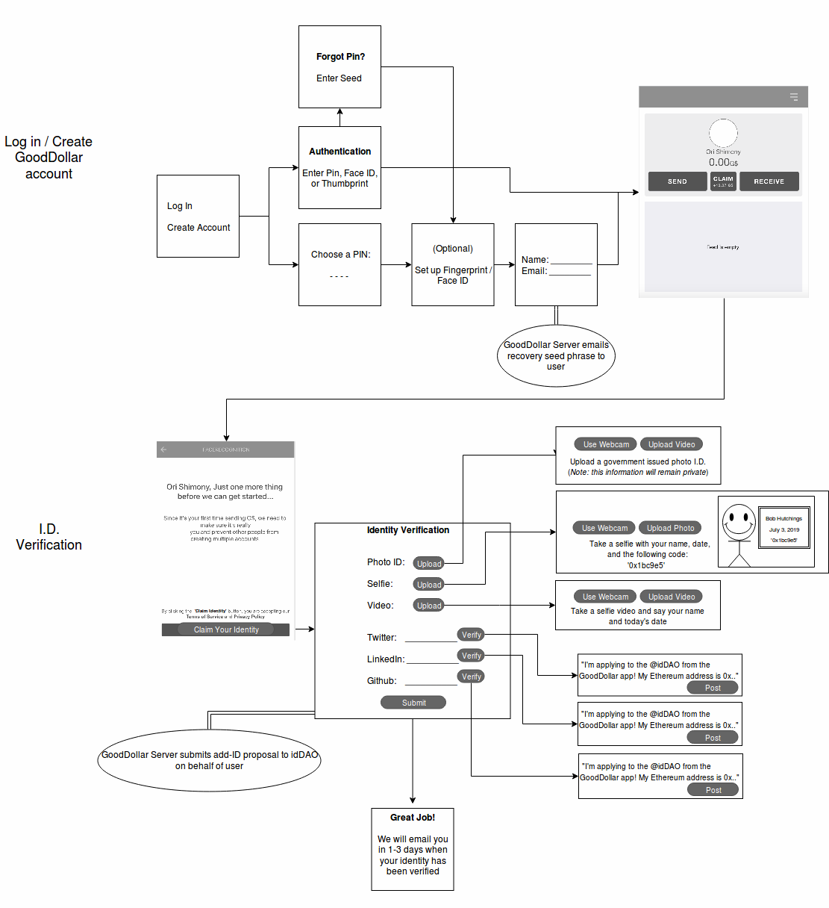

II. User Scenarios

Basic Scenarios

- Initial Account Creation
- User with GoodDollar account (signing in)
- New user verifying identity

Exceptional Scenarios

- User forgot their PIN
- User with rejected approval
- User with existing GoodDollar attempting to register

III. User Flows

Initial Account Creation:

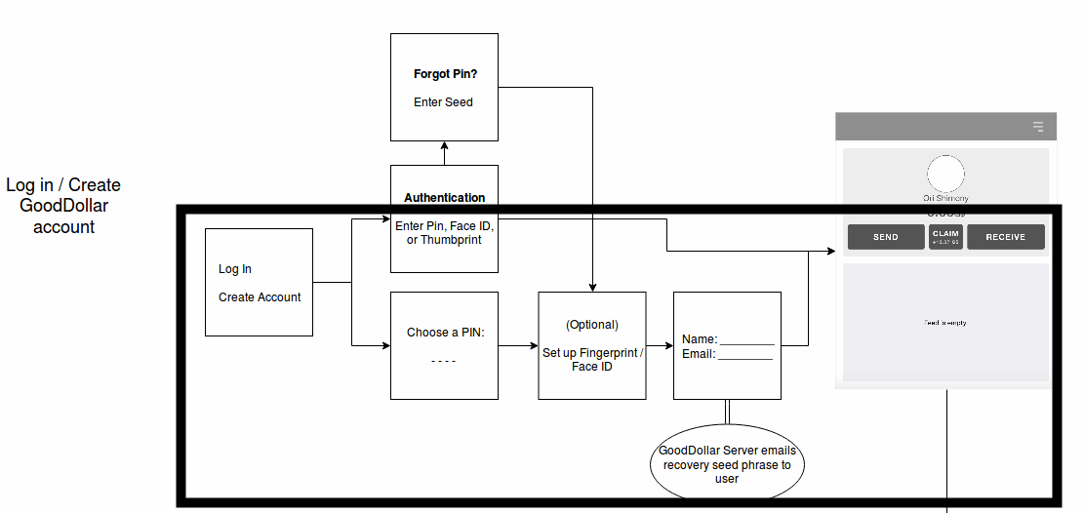

User with GoodDollar account (signing in):

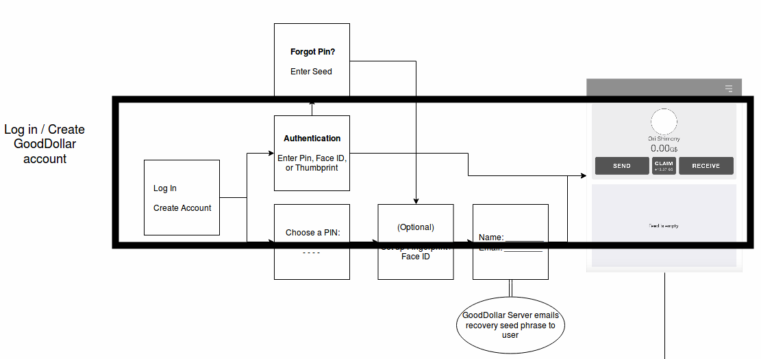

New user verifying identity:

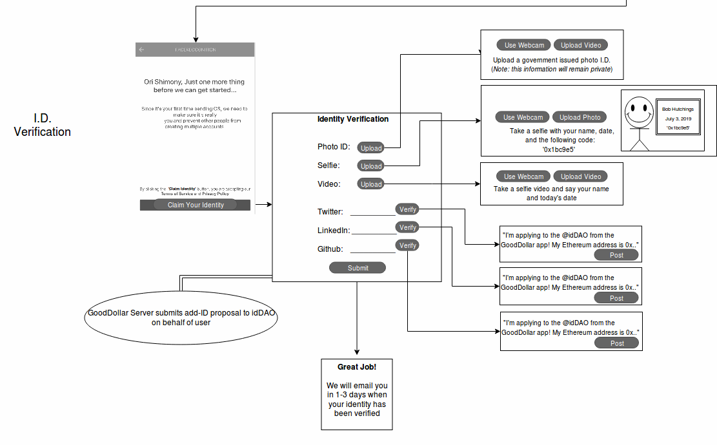

Exceptional Scenarios

- User forgot their PIN
- User with rejected approval
- User with existing GoodDollar attempting to register

User forgot their PIN

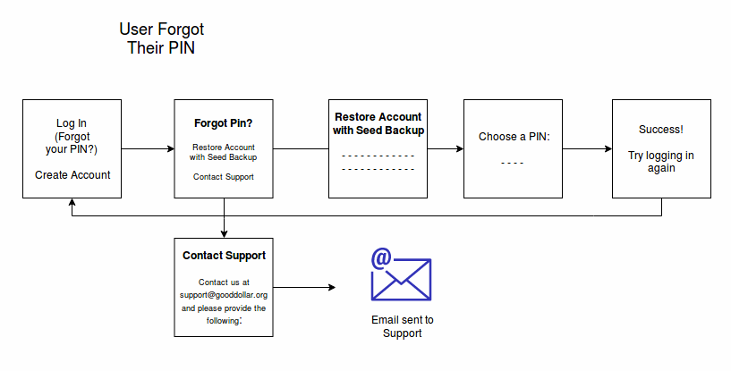

User with Rejected Approval:

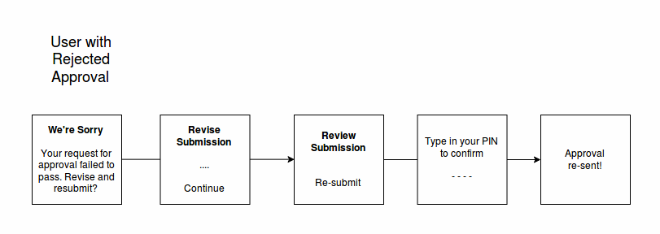

User with existing GoodDollar attempting to register:

